Day05 - Challenge01

1) Launch one aws ec2 and install jenkins.
- Open AWS EC2 and change the region to a nearest location which allows free tier. In this scenario I changed the location to ap-south-2(Hyderabad) which is the nearest location. Choosing the nearest region helps with less latency while connecting to the cloud resources.
- Launch an Instance with the below configurations
  - Ubuntu Server(Ubuntu Pro 26.04 LTS version)
  - t3.micro instance(comes under free tier). It has 2v CPU’s and a x86_64bit architecture.
  - Select a storage device which has upto 8GB. This comes under free tier and enough for launching and computing a linux OS.
  - For an instance to be connected through SSH, an RSA key pair is created. Then, a downloadable public key file with .pem extension is created.
  - Allow HTTP, HTTPS and SSH network traffic, this will create security groups allowing all inbound traffic from all kinds of ports.
  - It is mandatory to know that a VPC network instance will be created and billed. The network won’t be deleted even if the EC2 instance is deleted. Keeping an eye on the VPC billing will avoid unnecessary charges.
- Once an instance is launched with all the above settings, it will look something like this…
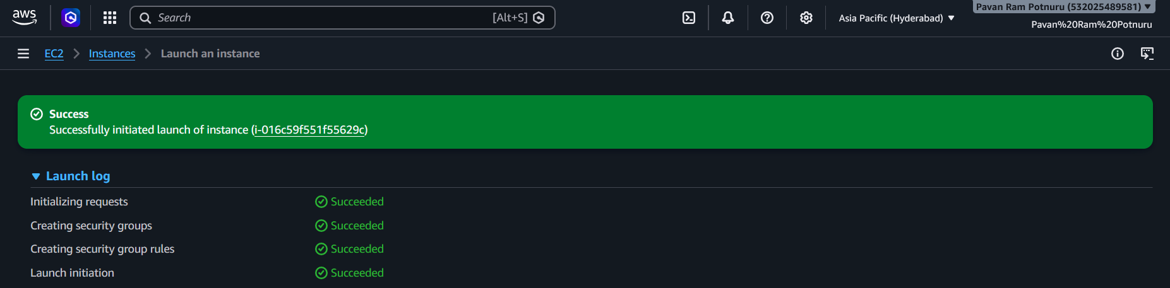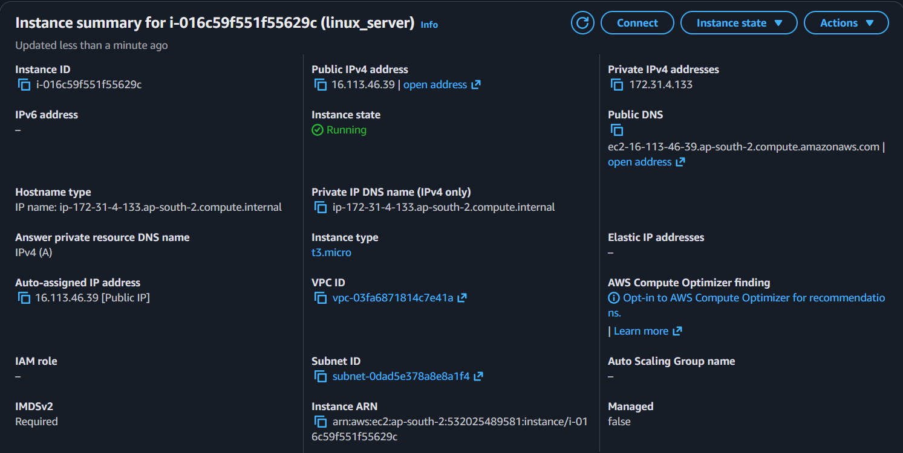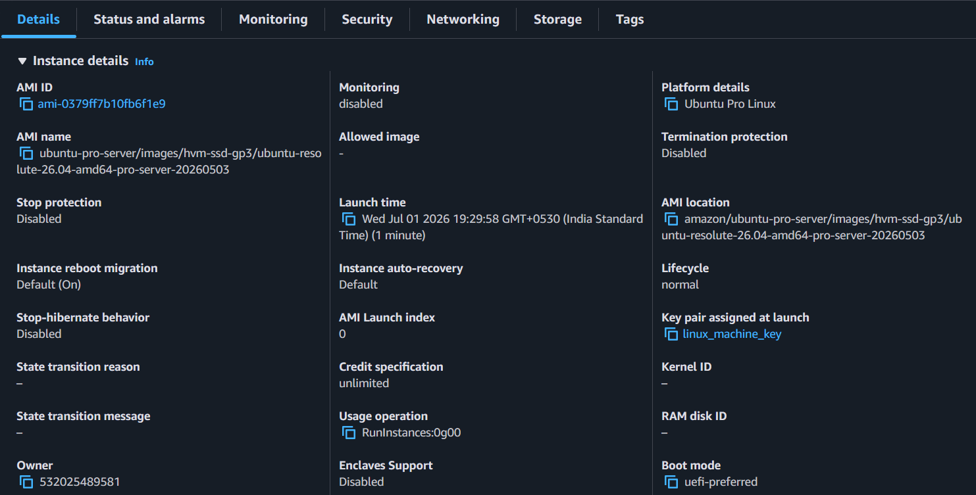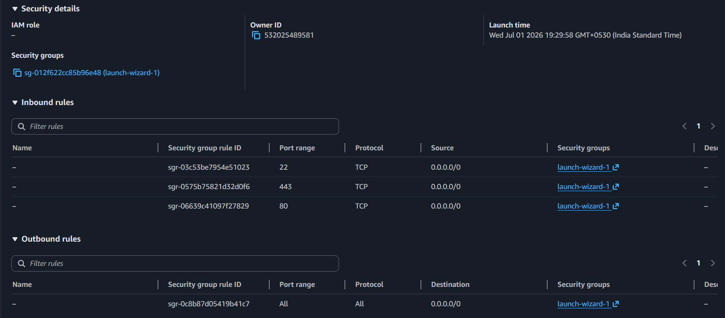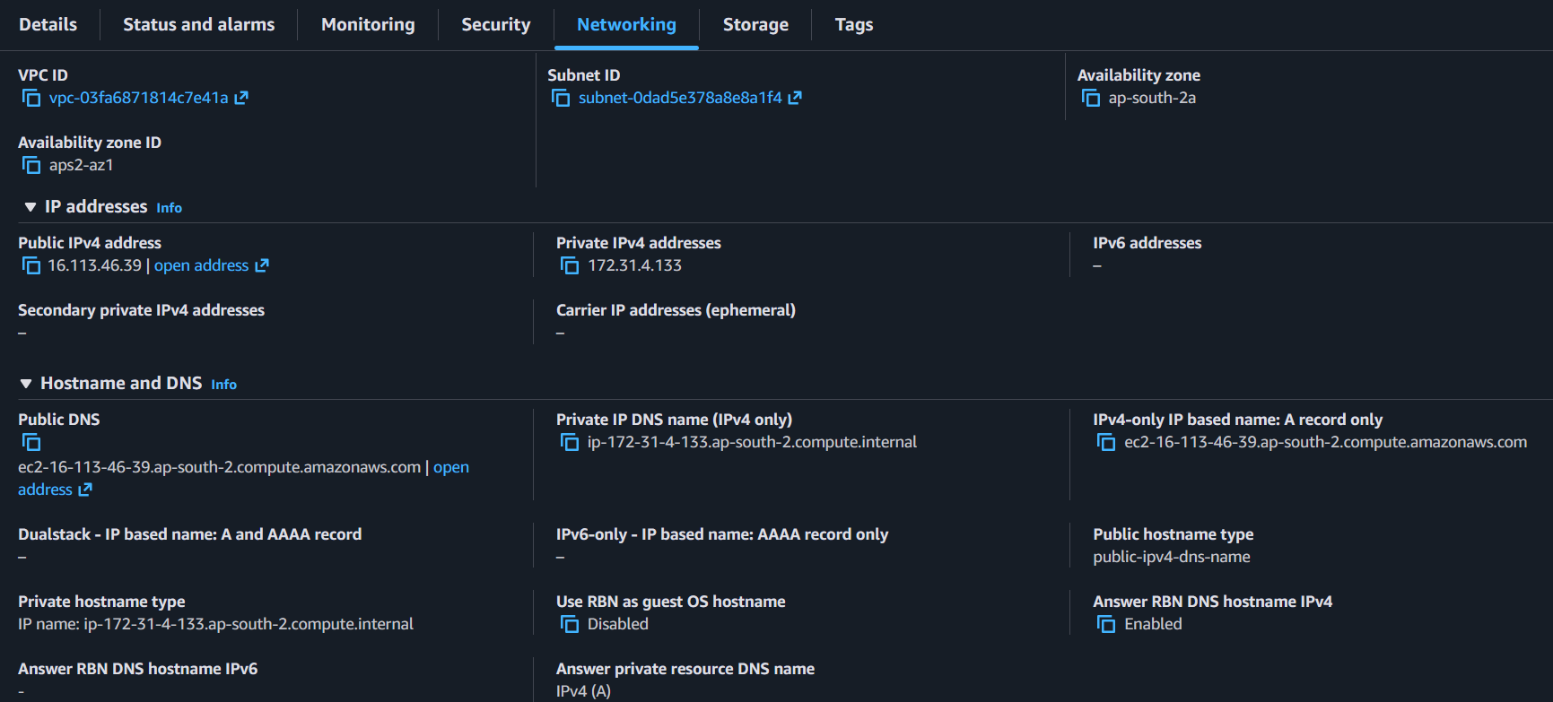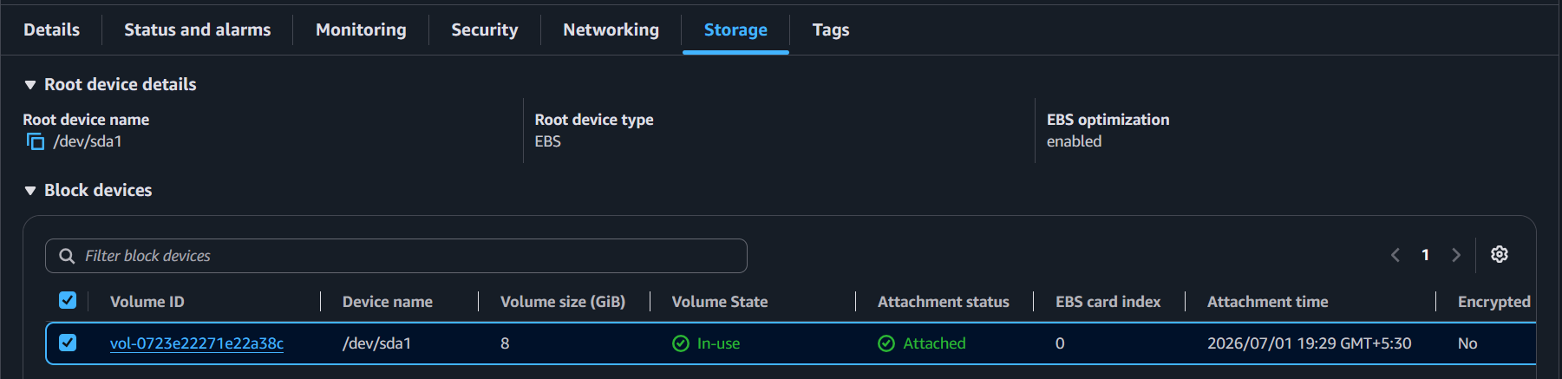
- Now that the EC2 instance is set, we need to connect to it via SSH. The below screenshot shows my connection establishment to the EC2 instance(linux_server) via SSH on my Macbook(Terminal) using the RSA public key(linux_machine_key.pem).
- Verify by referring to the private IpV4 address and the ‘hostname’ of the server you connected via ssh.
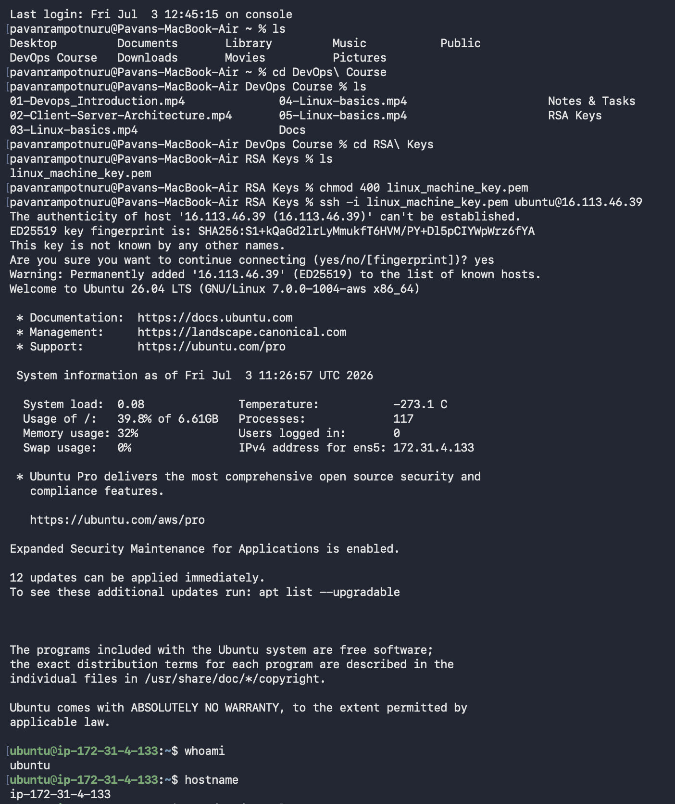
- Now since the linux_server is set up. Follow the below instructions to install Jenkins.
- Update system:-
  - sudo apt update
  - sudo apt upgrade -y
- Install Java 21:-
  - sudo apt install openjdk-21-jdk -y
- Verify Java
  - java -version
- Add Jenkins repository key
  - sudo wget -O /etc/apt/keyrings/jenkins-keyring.asc \
https://pkg.jenkins.io/debian-stable/jenkins.io-2023.key
- Add Jenkins repository
  - echo "deb [signed-by=/etc/apt/keyrings/jenkins-keyring.asc] \ https://pkg.jenkins.io/debian-stable binary/" | sudo tee \ /etc/apt/sources.list.d/jenkins.list > /dev/null
- Install Jenkins
  - sudo apt update
  - sudo apt install jenkins -y
- Create 2GB swap file (recommended for t2.micro/t3.micro)
  - sudo fallocate -l 2G /swapfile
  - sudo chmod 600 /swapfile
  - sudo mkswap /swapfile
  - sudo swapon /swapfile
  - echo '/swapfile none swap sw 0 0' | sudo tee -a /etc/fstab
- Verify memory and swap
  - free -h
- Once jenkins is installed in the linux_server, we have to create another inbound rule to allow traffic from the port 8080. This will help and ensure us to access jenkins web server on the 8080 port without any hassle.
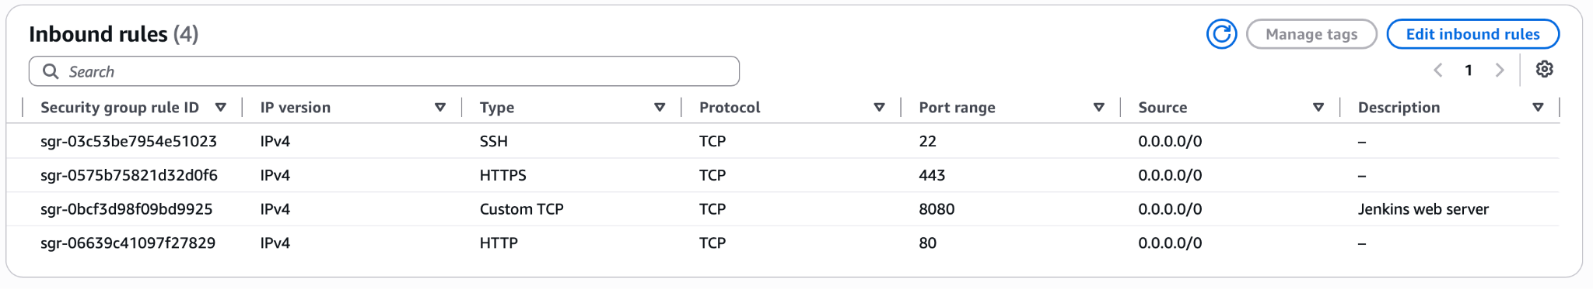
- Enable and start Jenkins
  - sudo systemctl daemon-reload
  - sudo systemctl enable jenkins
  - sudo systemctl start jenkins
- Check Jenkins status
  - sudo systemctl status jenkins
- Verify Jenkins is listening on port 8080
  - sudo ss -tulpn | grep 8080
- Get initial admin password
  - sudo cat /var/lib/jenkins/secrets/initialAdminPassword
- View Jenkins logs if needed
  - sudo journalctl -u jenkins -f
- Use the url http://<Linux_server public IP>:8080 to access the jenkins web server on the browser. In my case the url is http://16.113.46.39:8080
- You will be welcomed to the Jenkins server and once we hit ‘Continue’ the below screen will appear.
- Use the admin password to unlock jenkins, then install suggested plugins to get started.

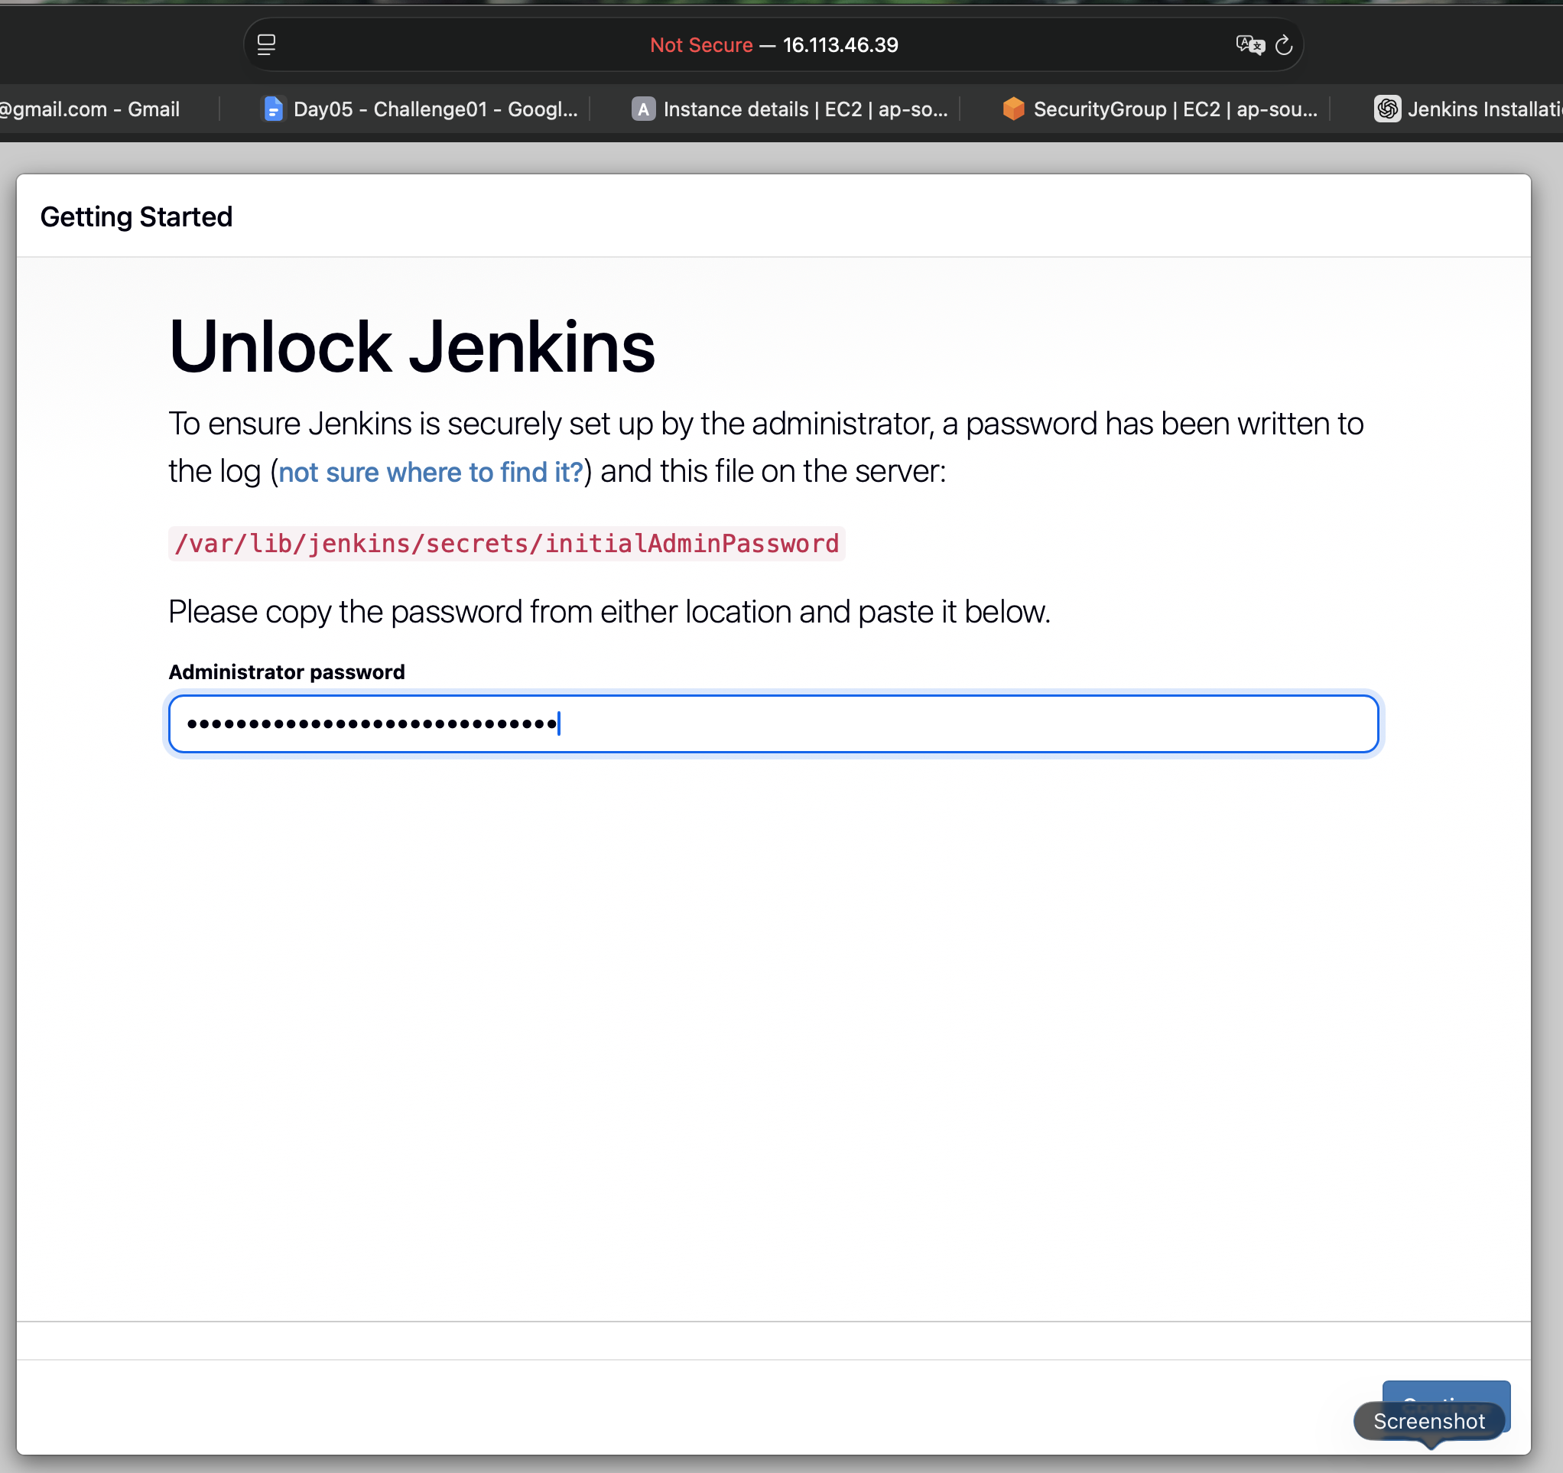
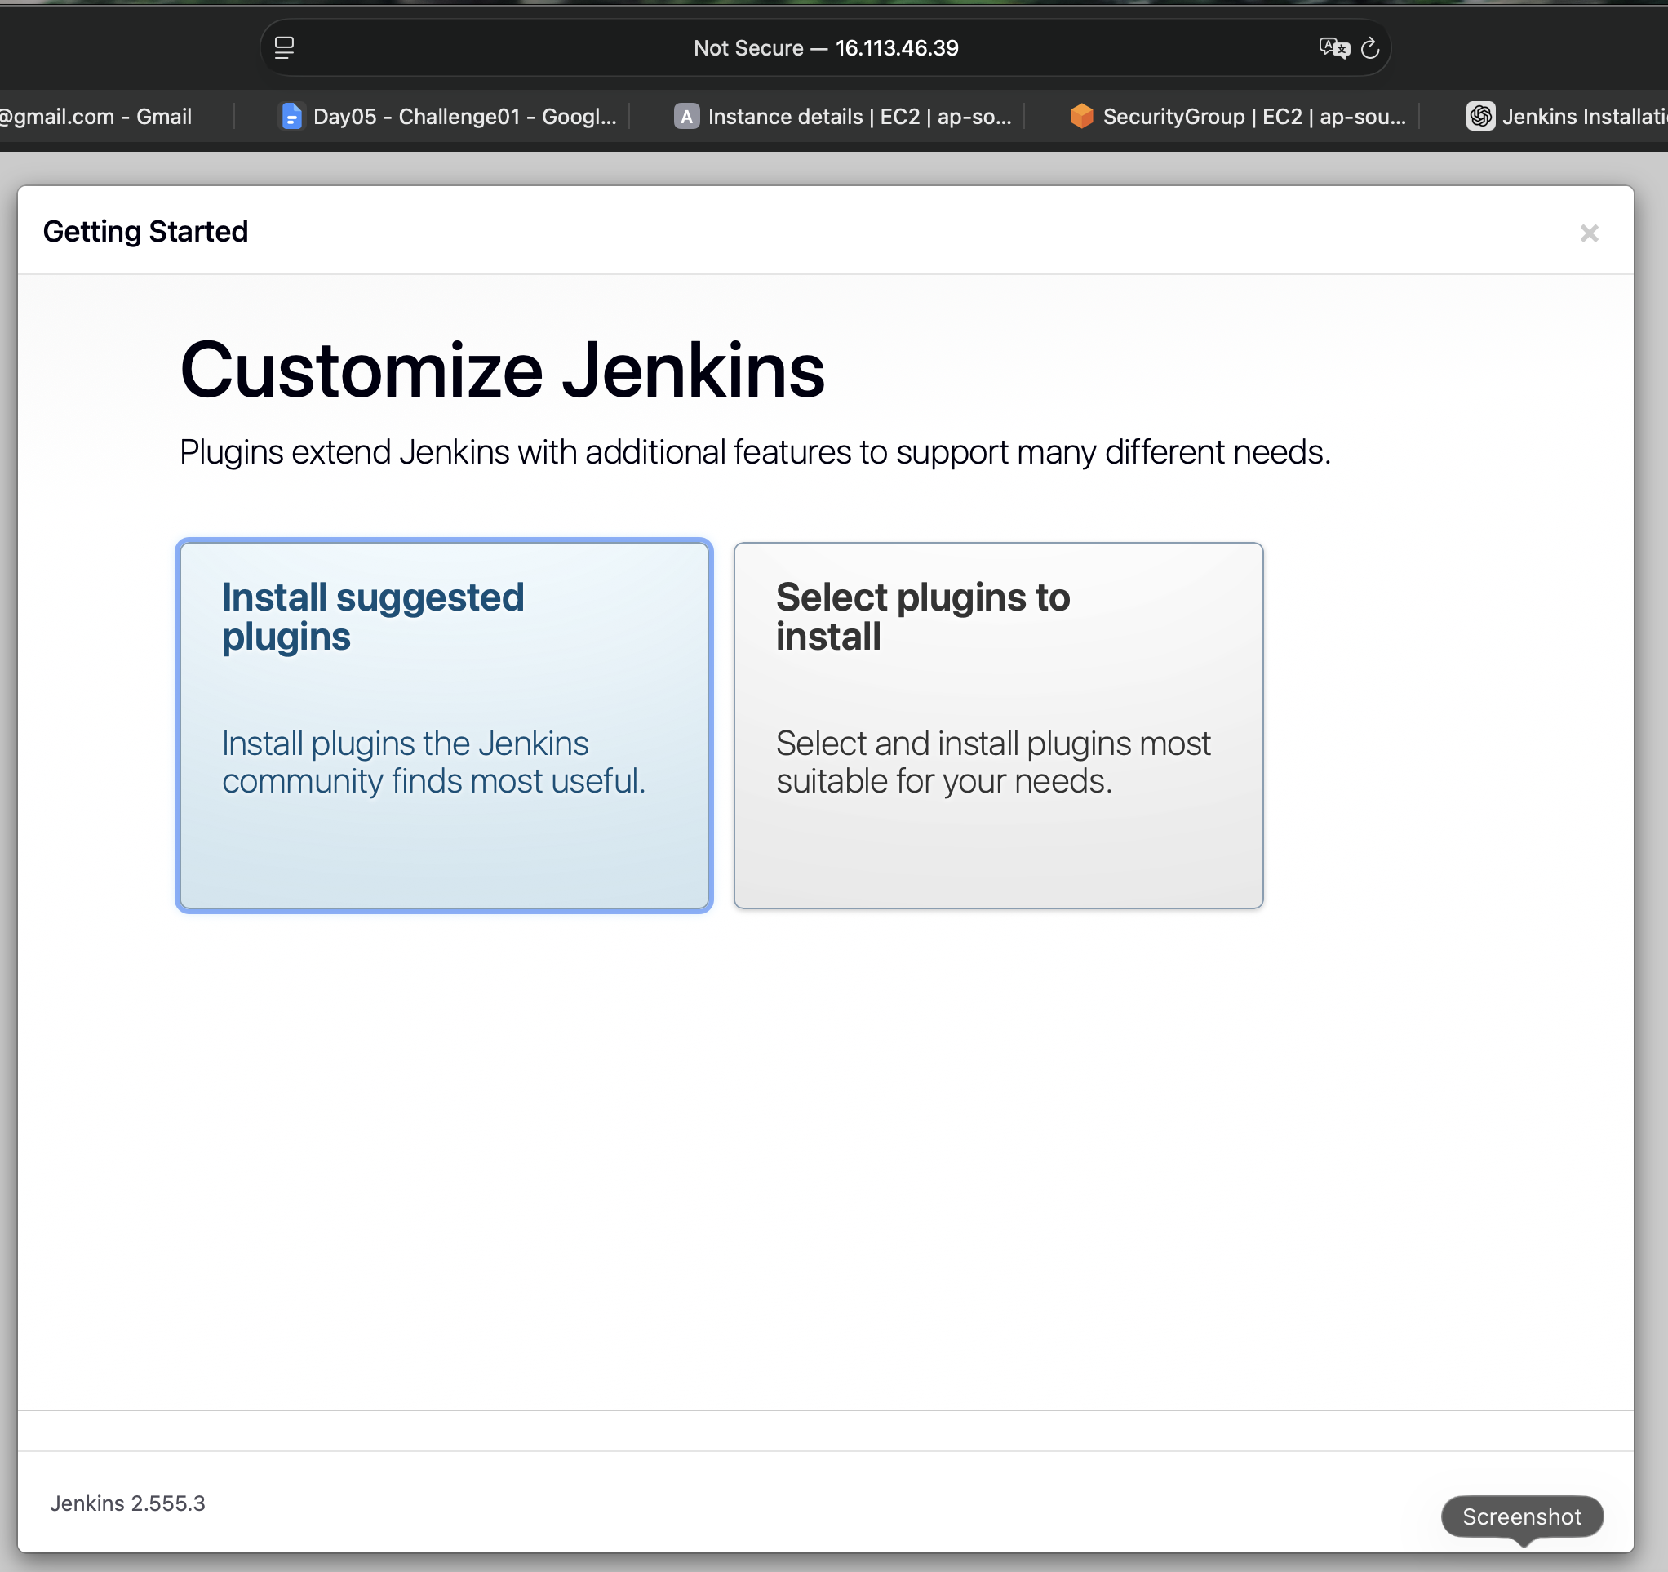
- Once the plugins are installed, the Jenkins server is ready to use.
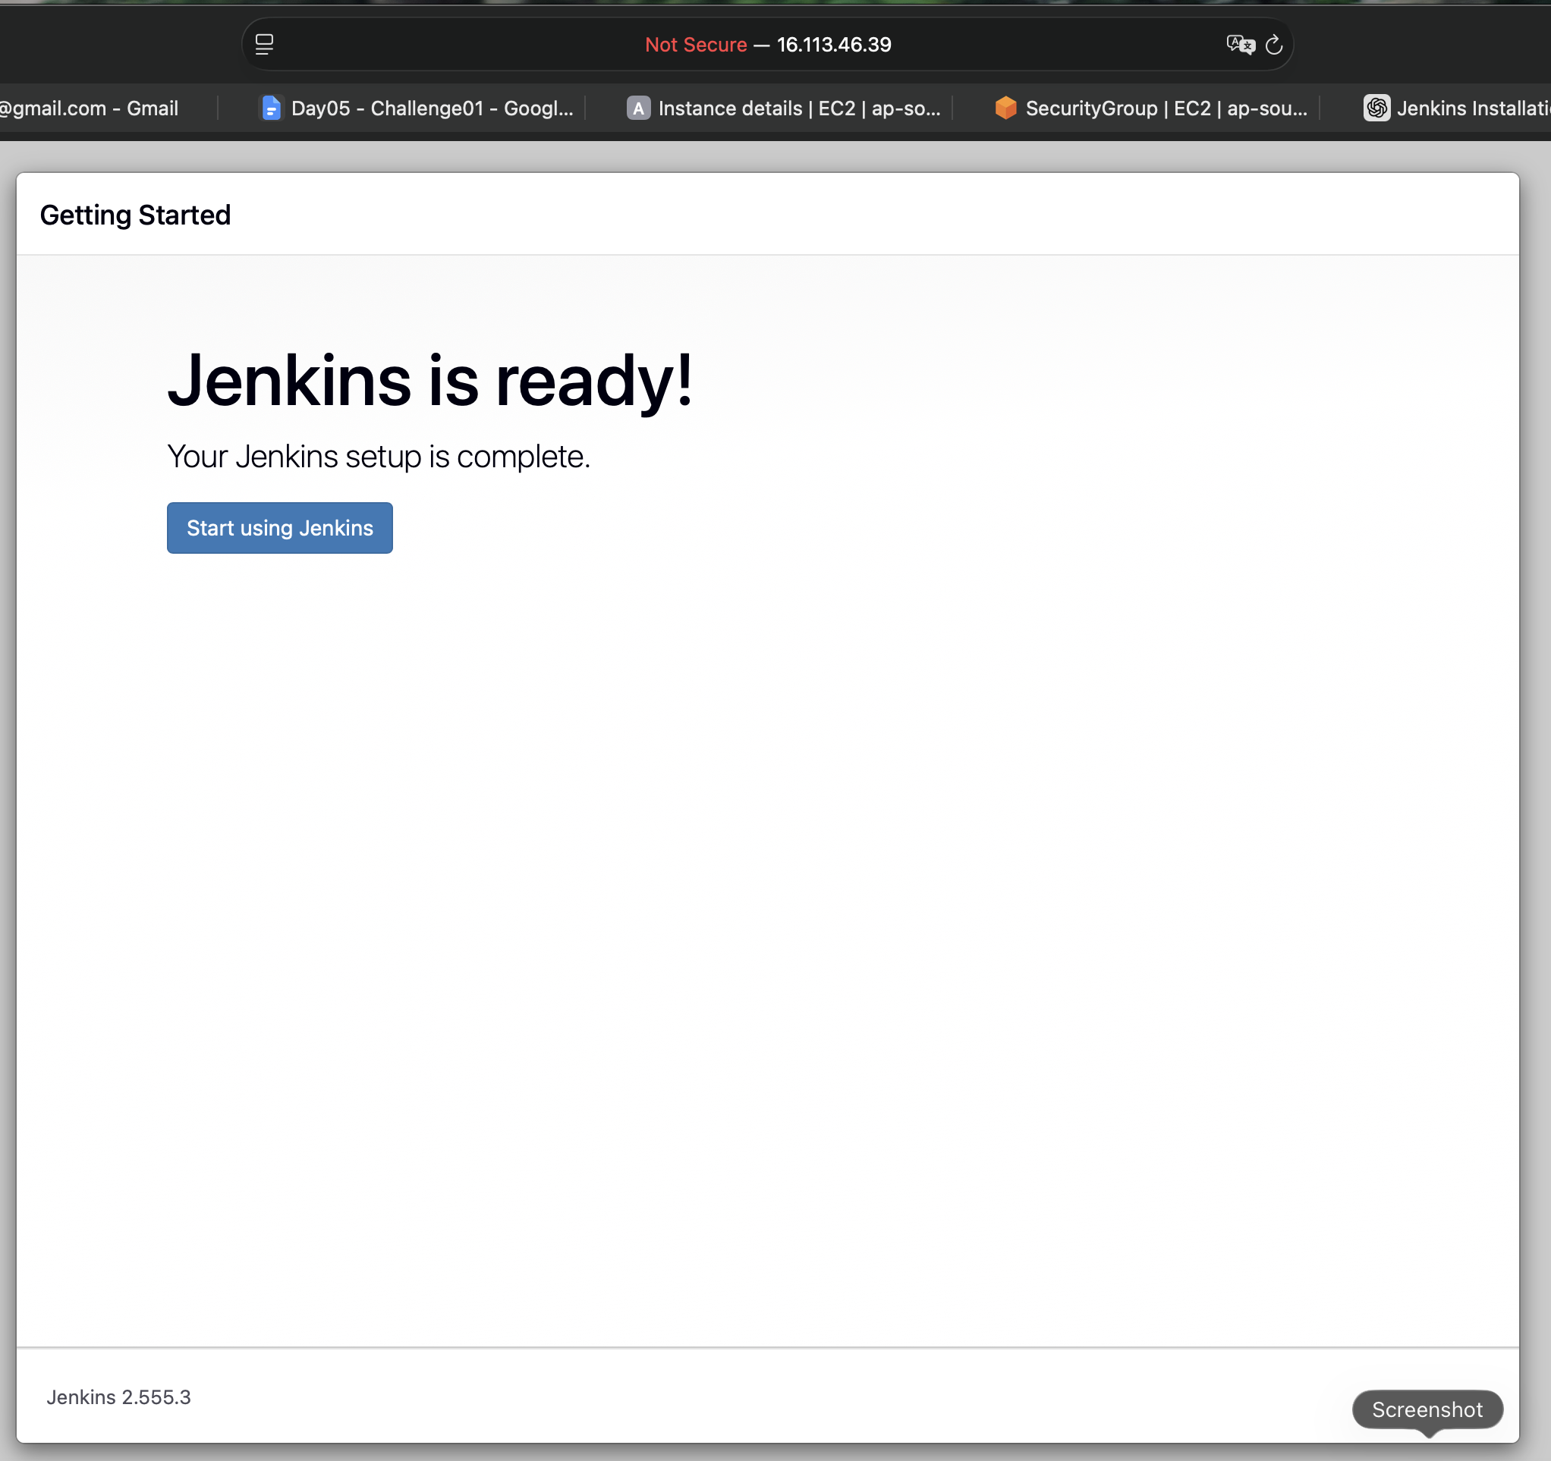
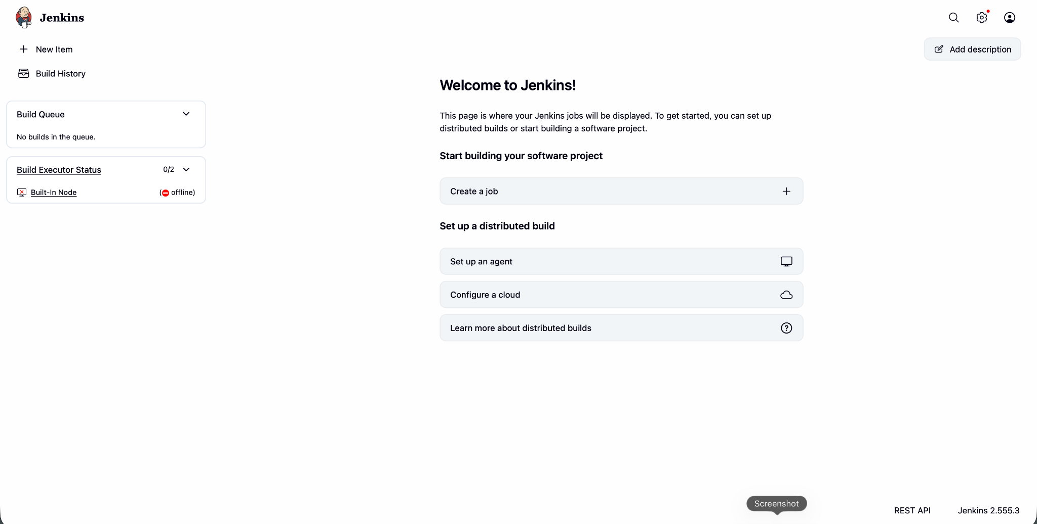

- Once the work is done make sure to stop the EC2 server. This will help us to save the billing costs.
- Stopping the EC2 instance, do not stop the EBS volume, which is being used as the storage device for the ec2 server. Along with this the VPC Network will also be running. These both AWS services will be billed based on their usages.

2) Setup Apache Tomcat on Ubuntu Virtual Machine
- Installing Apache requires the latest version of java in our server. In our scenario java21 was installed already while trying to install Jenkins in the previous challenge.
- Now Ubuntu Pro 26.04 LTS version comes with a tomcat 11 package in its list of apt packages, which can be used to install without downloading any packages nor setting any paths.
- Follow the below commands to install Apache Tomcat 11
  - sudo apt update
  - sudo apt install tomcat11 tomcat11-admin -y - Command to install tomcat11 package
  - sudo systemctl status tomcat11 - Command used to check the status of Jenkins applications. The contents will show the status of its installation or any systematic errors
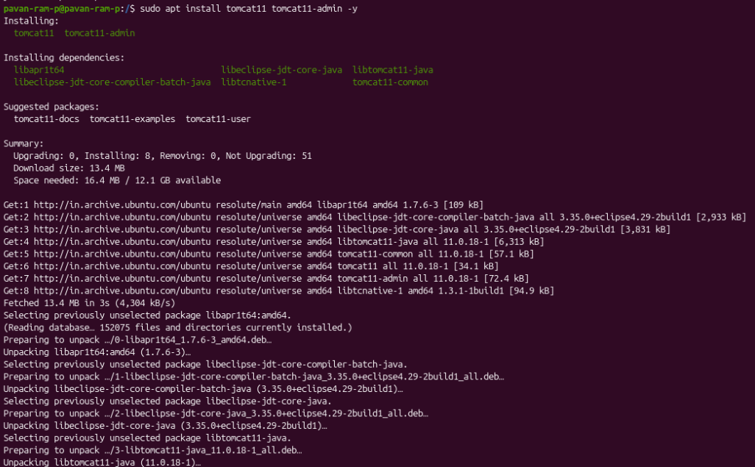
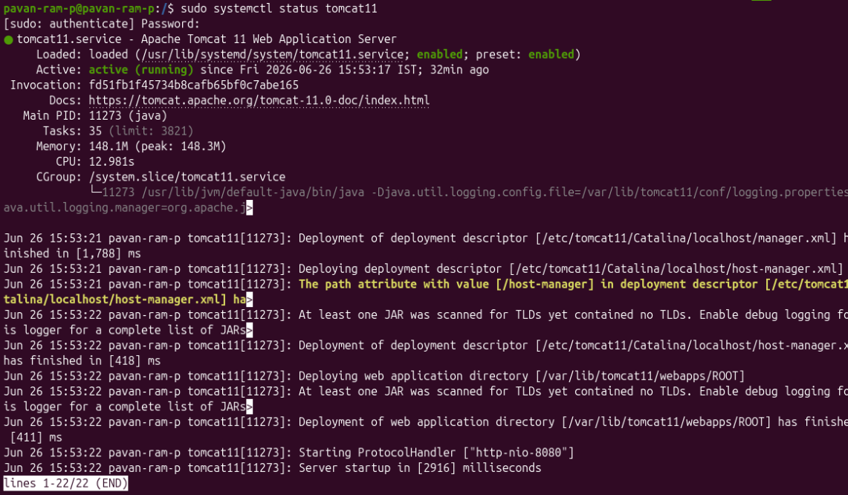
  - sudo systemctl start tomcat11 - This will start the server and will be ready to use.
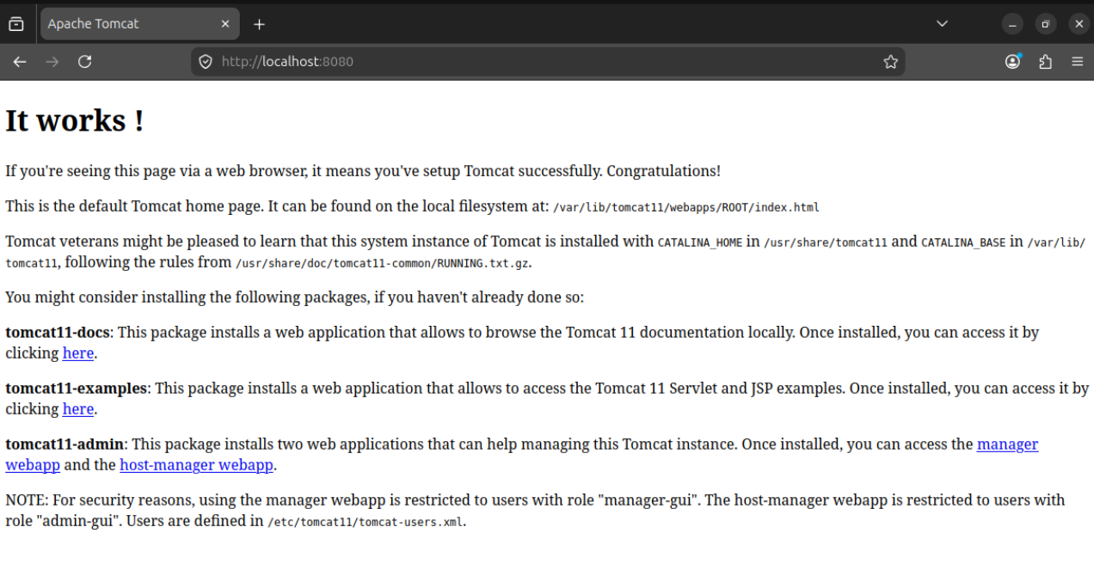
  - Note that Tomcat also uses the port 8080. Since this is already added to the security group, we might not get into any trouble while accessing the server.
  - Sometimes when we are using both the servers(Tomcat and Jenkins) at a time, there will be an issue while connecting to one or the other server. To avoid that, adding a security group allowing traffic ports ranging from 1000-9999 will help.
3) Setup Docker Desktop on your local machine.

- Download and install docker desktop from the web. Once it is installed, open the docker application. We will be asked to install the docker command line package to run docker commands on your local terminal. Once the whole setup is done, the docker desktop application looks like this…
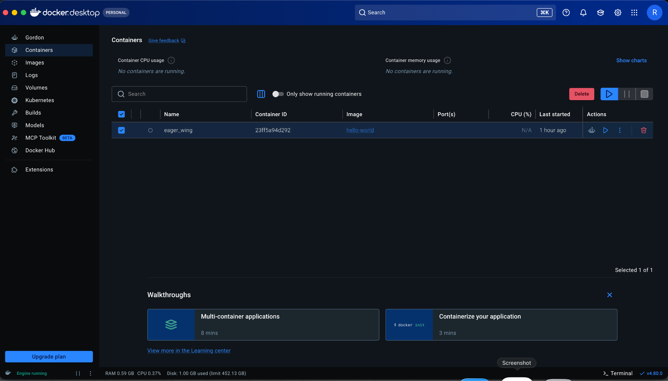
- Now open Terminal on your local machine and follow the below commands to know more about docker.
  - docker –version :- Command used to know the version
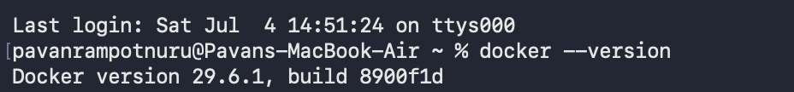
  - docker info :- Command used to get all the details of docker and the installed plugins to run docker.
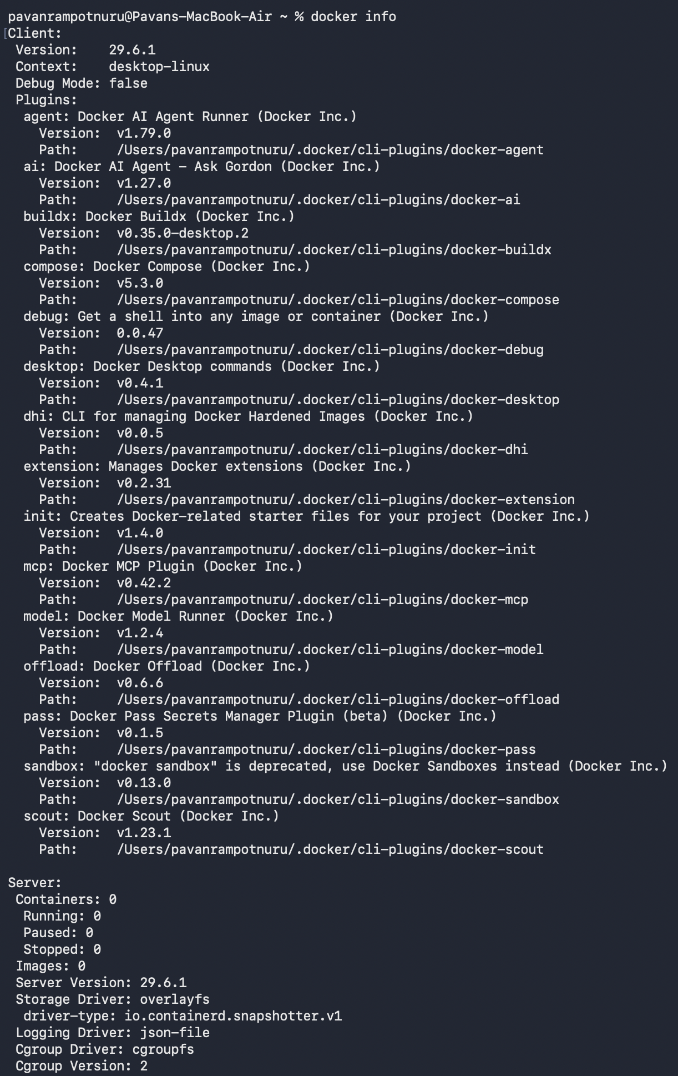
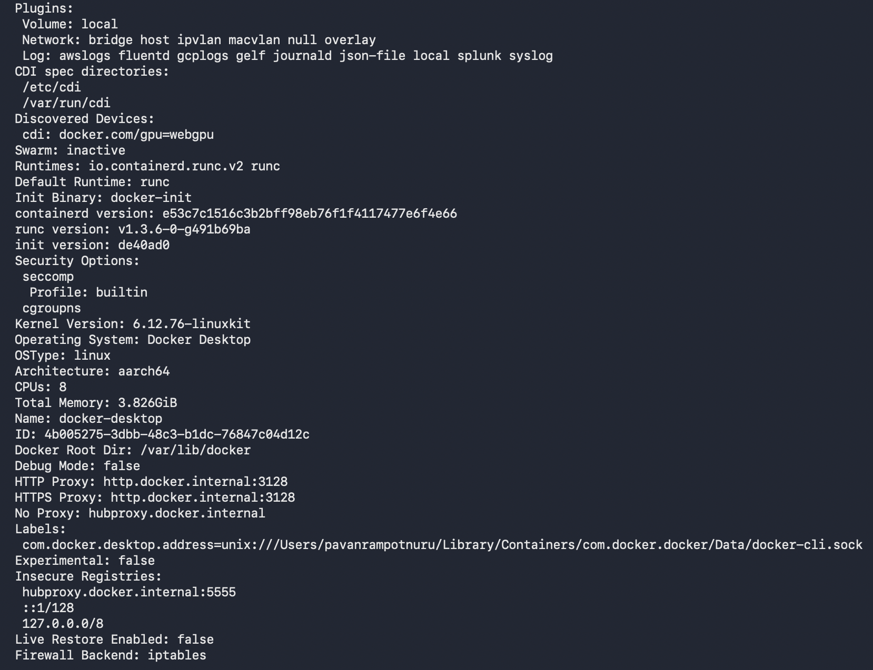
  - docker run hello-world - Run this command to test if docker is working perfectly or not, this command runs a pre-developed image on its container and gives the result “Hello from Docker!” and it also performs a health check on the docker installation process.
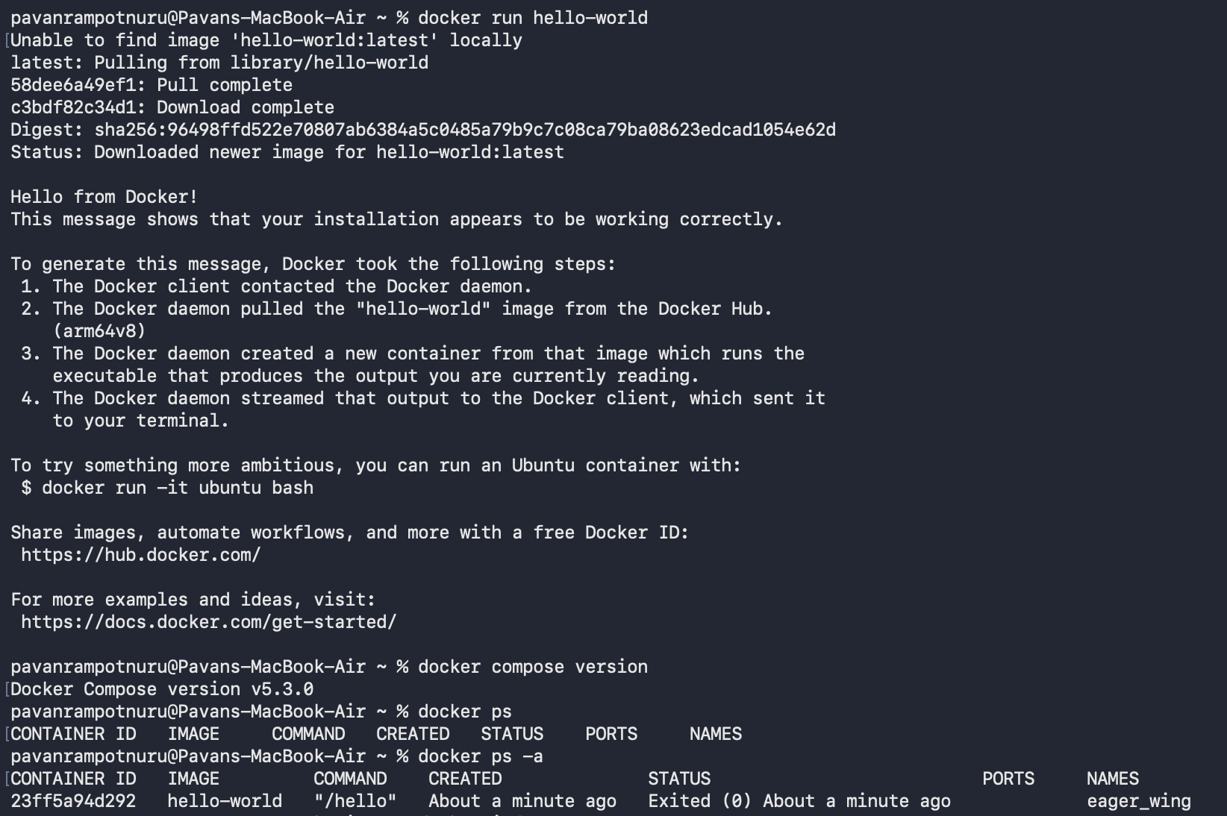
  - docker ps :- This command is used to get all the processes which are in running state in the docker containers
    - -a : This flag is used to get all the running, terminated and existing processes which used docker containers.

